COMMUNITY SERVICE PROJECT

IMPACT OF SMART PHONE





#### DEPARTMENT OF COMPUTER SCIENCE AND ENGINEERING SIR C. R. REDDY COLLEGE OF ENGINEERING

**(Affiliated to Jawaharlal Nehru Technological University, Kakinada)**

IMPACT OF SMART PHONE

A Community Service Project Report is submitted in partial fulfilment of the requirements for the award of the Degree of

###### BACHELOR OF TECHNOLOGY IN

**COMPUTER SCINCE AND ENGINEERING**

Submitted by **P.ANJANEYULU Reg.No:20B81A05D3**

Under the Esteemed Guidance of

Smt.P.Chaitanya



#### DEPARTMENT OF INFORMATION TECHNOLOGY SIR C.R.REDDY COLLEGE OF ENGINEERING

**Approved by AICTE Eluru-534007**

#### 2022-2023

SIR C.R. REDDY COLLEGE OF ENGINEERING

(Affiliated to Jawaharlal Nehru Technological University, Kakinada)

ELURU, W.G.Dist., (A.P)



CERTIFICATE

This is to certify that this is a Bonafede record of the project work entitled " THE IMPACT OF SMART PHONES AND MOBILE DEVICES ON HUMAN HEALTH AND LIFE done by **P.ANJANEYULU** bearing Regd no **20B81A05D3** a student III-B.Tech., 5th semester in the Department of Computer Science and Engineering of Sir C.R. Reddy College Of Engineering, Eluru, during academic year 2022-2023

**Smt.P.Chaitanya Dr. A. YESU BABU Ph. D**

**GUIDE HEAD OF DEPARTMENT CSE**

###### DEPARTMENT OF CSE SIR CRR COE, ELURU SIR CRR COE, ELURU

**DECLARATION**

I am P.ANJANEYULU a student of III B. Tech I Semester Compute Science & Engineering Department, SIR CRR COLLEGE OF ENGINEEING*,* has successfully completed the Community Service Project report entitled “IMPACT ON SMART PHONES” ,which has been carried out by me under the esteemed guidance of P.Chaitanya, Department of CSE. I declare that above work is not submitted at any university for award of any degree.

P. Anjaneyulu

20B81A05D3

#### ACKNOWLEDGEMENT

I wish to express my sincere thanks to various personalities who were responsible for the successful completion of this project.

I express my sincere thanks to our principal **Dr. K.VENKATESWARA RAO** for providing the necessary infrastructure required for our project.

I am grateful to **Dr. A. YESU BABU** Head of the department of CSE for providing the necessary facilities and his guidance in the efficient completion of the project in specified time.

I express my deep-felt gratitude to P. CHAITANYA(madam), Department of CSE for his valuable guidance and unstinting encouragement enabled us to accomplish our project successfully in time.

Last but not least I also express my sincere thanks to all the faculty members of the Department, and my family and friends for their help and co-operation in completing the project.

#### CONTENTS

###### CHAPTER-1:

INTRODUCTION

* 1. ABOUT SMART PHONES AND IT’S IMPACT ON HUMAN HEALTH AND LIFN
  2. DATA COLLECTION
  3. METHODLOGY FOR DATA ANALYSIS
  4. 1.4 OBJECTIVES OF THE STUDY

###### CHAPTER-2:

* 1. DATA ANALYSYS
  2. DATA TABLES

###### CHAPTER-3:

ANALYSIS THROUGH VARIOUS TESTS

###### CHAPTER-4:

QUESTIONNAIRE

###### CHAPTER-5:

CONCLUSION

###### CHAPTER-6:

BIBLIOGRAPHY

#### A COMMUNITY SERVICE PROJECT REPORT

ON

**THE IMPACT OF SMART PHONES AND MOBILE DEVICES ON HUMAN HEALTH AND LIFE**

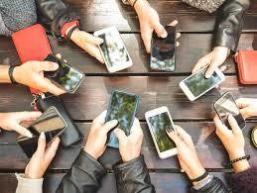

## INTRODUCTION

#### Introduction

Smartphones first introduced in “MARTIN COPPER” the advent of new touch technologies and wide spread use of smart phones and Be devices have made humans embrace with technology more And extensively dependent upon them. The wireless devices like cell chones, tablet, laptops, audio players, and digital cameras are used by Af which are connected to used by wifi which are connected to exchange information. Social networks allow people to interact and make new friends but their use without any knowledge will result in harmful effects..

Today, it’s is estimated that more than 5 billion people have mobile pe.ices, although the mobile phones makes our life smooth but it has many evil effects also. The smart phones or the mobile phone might be affecting one’s thought process, behaviour and attitudes in a more regative and faster way. It does that finely and secretly that is becomes difficult to identity to identity and cope up with.

It is not an exaggeration to say that smart phones have the power to influence most important decision making processes and choices. Trama and high level anxiety pains. Addiction remains online, compulsion to be active on social sites leads to low productivity and impact the emotional health of the person constantly looking for something interesting on web, social sites and games inhibits ones emotional ability to focus on one topic for long. It has been already proved that long hour of gaming makes anyone impatient, addicted and unproductive long time effects may be worse, permanent and effecting more subconscious layer of behaviour so that suggestion is to Leep phone away for a while and enjoy all the good things life to offer.

In 21th Century everything in the plam of our hands, technology has reached its peak and it’s still developing to a new everyday. The smallest piece of technology can cause a big change in our daily life mobile phone is one of the faster growing technology in the least few decades.

The intension of this study is to investigate how smartphones are acting the society and also how smartphone are going to transform the cultures social life, technology landscape and other diverse aspects of modern society the intention of this study is to understand all positive and negative aspects of smartphone on the society. The will primarily focus on impact of smartphone on business., education, health structure, human psychology, social life at the end, the study will summarize the impact and conclude based on wide range of impact that smartphones have society the paper will also recommended solutions, in order to reduce the negative impact of smartphones and realize more of this exting technology.

**SCOPE**

**Scope**

The use of mobile internet devices (MIDS) smart ones and proprietary software applications can improve unication among medical care giver.

The utilization among medical of these mobile technologies has further transformed Healthcare communication, commerce education and entertainment among other field never technology have the potential to be adapted for improvement in the Healthcare and medical education Smart phones and mobile phones are now almost integral part almost every person in the globe as it is hot good for health more research work should be done on prolonged usage of smart phones when most of the household goods will be operated by smartphone especially the pertinent women’s and children are in greater population may involve in the further studies it can be collected by different diversity to rule out the methods of reducing adverse effect of mobile phone usage the smart phone or mobile phone has become 24 hours attachment with most of the users all over the globe.

The main advantage of using smart phone or mobile phones is that it keep user ‘Online it is important to point out that smart phone have changed the way we access internet and benefits from the macro computer and smartphone with strong hard ware capabilities, extsve mobile operating system. The smartphone has changed our life for the better in some ways. The simulation result showed that the proposed algorithm preform Better with the total transmission energy metric.

The use of mobile technologies in teaching and training has beam used as complimentary resource for interaction between student and instructor for motivation and learning.

# OBJECTIVE

#### OBJECTIVES

The main Purpose is to determine the impact of the increased use of mobile phones on youth’s health.

* The second purpose is to identify the factors that contributes to the increased use of mobile phones among
* The third purpose is to measure the awareness and responsiveness and its harmful effects among the youth.
* Examine why people are using mobile data.
* Understand the level ofjusage of mobile data day part .
* Over use of smart devices provides comfort ad problems both physically mentally.
* That increased use of mobile device hampered family life through if reduced quality family time.
* Majorly users experienced physical discomfort after prolonged use and suffered from head ache.
* If RF radiations is high enough it has a thermal effect which means it raises body temperature there are concerns that the low level of RF radiations emitted by mobile phone could cause health problems such as headache or brain tumorous.
* To highlight the impacts of smart phones on the life of young generation.
* To measure to proper usage of mobile phones among academic year
* To study aimed to study the mobile phone addiction behaviour and awareness on electromagnetic radiation (EMRJamong a simple of Malaysian population methods this online study was conducted between Domber 2015 and 2016 the study instrument copra

Mused eight segments namely informed content from demographic Details, habituation, mobile phone awareness education, anxious behaviour analysis and health issues.

* To identify impact of technology generally the mobile technology the less educated people in developing countries.
* And to identify how rapidly changing the human behaviour by using mobile technology or mobile phone in all countries.
* Also identify the impacts of mobile phone and rate of unawareness regarding the use of technology.
* To objectives of this study was to investing the prevalence a smartphone addiction among middle eastern post graduates students, determine the factors associated with smart phones addiction and estimates the incidence rate of major depressive disorder (MDD), AHD, insomnia pcothe addiction among students with smartphones.
* To study was designed to investigates the revised and short of the smart phone’s addiction scale and the proof of its validity in adolescents.

# METHODOLOGY

#### METHODOLOGY

The impact of smart phones and mobile devices on human health and life. Over use of smart devices provides comfort and problems both physically and mentally

The Survey also included a section related to major issues and respondent awareness regarding the wide spread and use of smart phones. The study revealed the most of the respondents used smart phones for communication where nearly half used for less than Shours daily. It also found that majorityb had other electronic devices. Commonly were laptop users usedv for studying among which majority used for less than 5 hours daily.

The intension of this study is to investigate how smart phones are impacting the society and also how smart phones are going to transform the culture. Social life technology landscape and other diverse aspects of modern society. The intension of this study to understand all the positive and negative aspects of smart phoneb onb the society.The study will primarily focus on impact on smart phone on business, education, health sectors and human psychology and social life.

A literature study is conducted in to the existing literature in order to define the characteristics of a ‘typical’ smart phone. Focus is given to Green House Gas (GHG) emissions in different life cycle phases in line with that reported in the majority of literature usage patterns from literature are presented in order to show how a smart phone

Is increasingly responsible for not only data consumption but as data generation. The subsequent consequences of this for the balance of the life cycle phases are explored with the inclusion of wider elements in the potential expanded mobile infrastructure, such as servers and the network.

###### PRIMARY DATA:

Data collection is a step in any research design or program. In order to be analysed this collected data needs to be entered in to a spread sheet or statistical software transcribing paper based data is time consuming and often associated with errors Such errors may be due to an inability to read the data collectors hand writing, human mistakes during data entry etc. A system where in a data automatically gets transcribed and uploaded in a data base during data collection would be of immense use in this situation. A possible solution for this

mobile phone based data collection with the advent of newer technology software solutions this process can ever be done on a standard entry level mobile phone.

The study participants were aware about mobile phones. There are lots of ways to collect data while mobile the explosive growth in the avoidability of mobile phones in societies around the world. In a few years, the world coverage of mobile phone subscriptions has raised from 12% of the world. Population In 2000 to 96%. A possible solution for this is mobile phone based data collection a type of electronic data capture methods.

Smart phone has impacted all most all walk of human life The prominent areas, where impacts of smart phone are obvious include business, education, health and social life. Mobile technology has drastically changed the cultural norms and behaviour of individuals The impacts are both at the positive side and also at the negative side At one end smart phone are abling people to create their own microculture and engage in activities considered dangerous of society.

The mobile technology has drastically changed the cultural norms and behaviour of individuals There has been a drastic growth in broad band and internet service providers business in past few years and one of the main reason for this drastic increase in their business is the ever increasing use of smart phones and growth of smart phone is on pc market. According to a survey by compete a web analytics firm, a large number of people almost up to 65% are using their smart phones to read news feeds .post status updates,read and reply messages and post photos.

Use of the internet has become a part of life of every student and a mean to search for the information as and when it is needed. Along with their fantastic facilities, smart phones enables students to text,cooperate on social networking sites check e- mails, Play online games, and even watch TV channels this is one of the sources of distraction.The excessive exposure of these devices in early age can cause poor eye sight for kids.

###### SECONDARY DATA:

Smart phones within and without the classrooms make it easier for students and teachers to collaborate Today smart phones are the most commonly used devices for communications and almost 27% of the consumers use smart phones for online activities infact some surprising statistics are there about the use of smart phones for chatting.

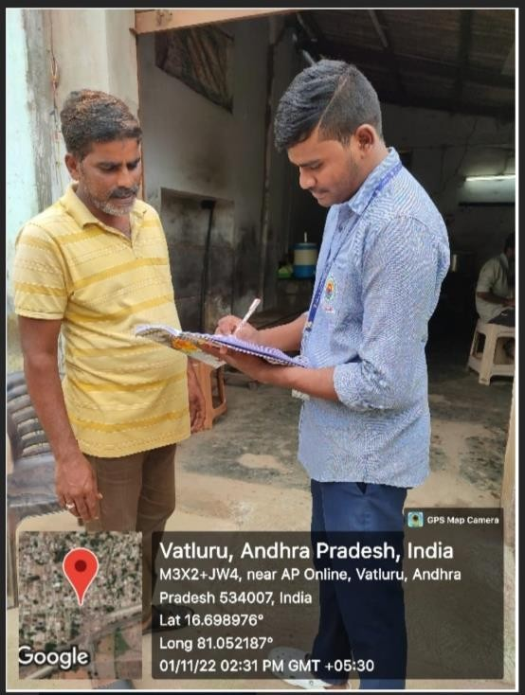 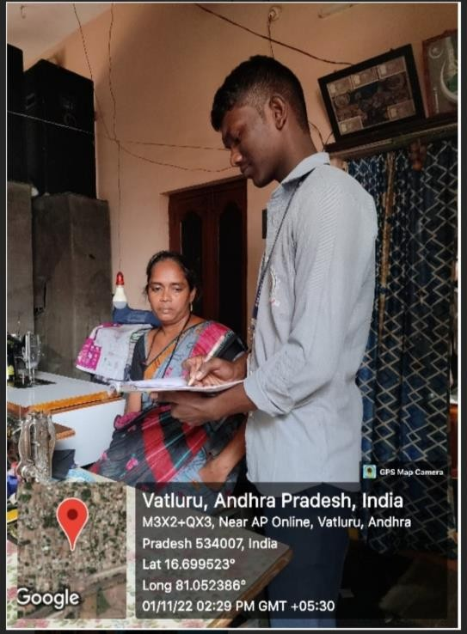

Name: P.JATHIN Name: P.GOPI KIRAN

Regd No:20B81A05D0 Regd No:20B81A05D5

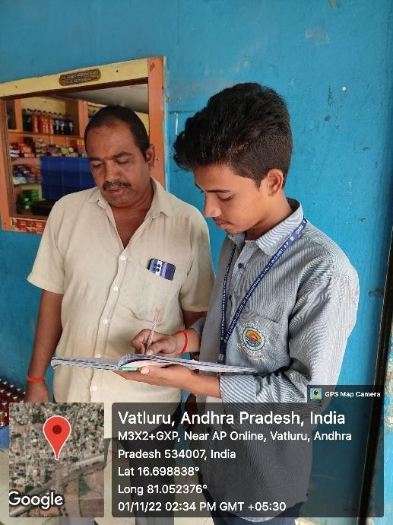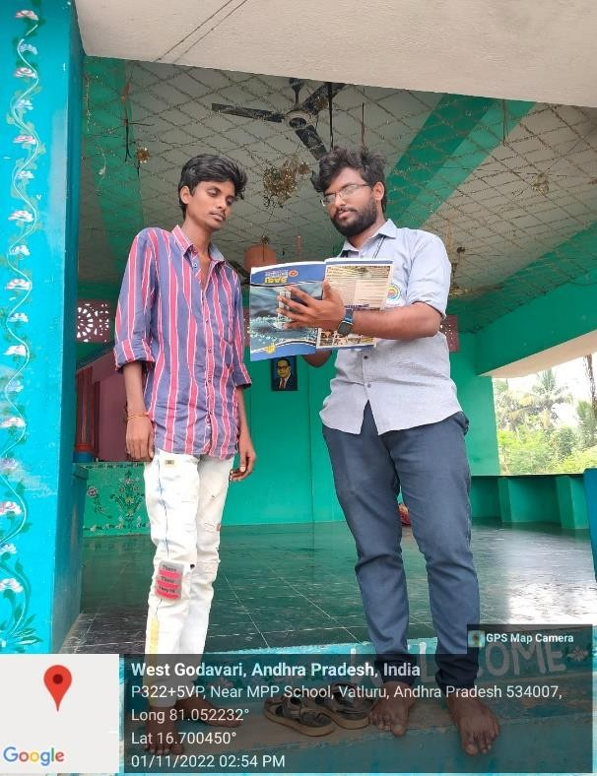

Name: S.BHAVAN RAM Name: P.ANJANEYULU

Regd No:20B81A05F0 Regd No:20B81A05D3

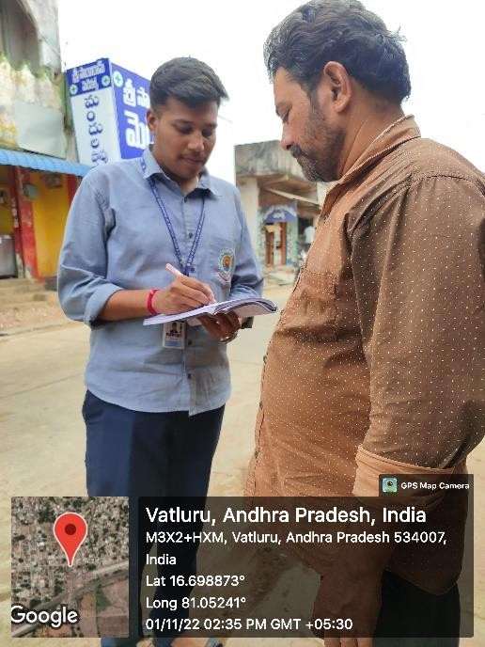 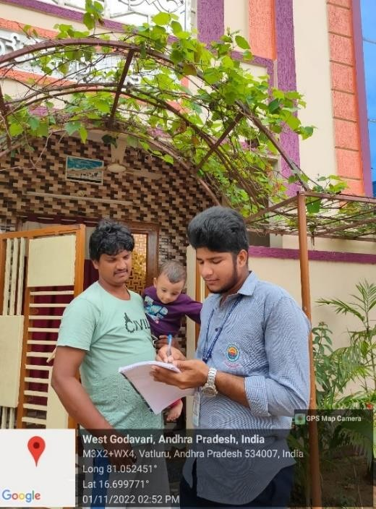

Name: P.SREEKANTH Name:R.CHINA RAYUDU

Regd No:20B81A05E2 Regd No:20B81A05E5

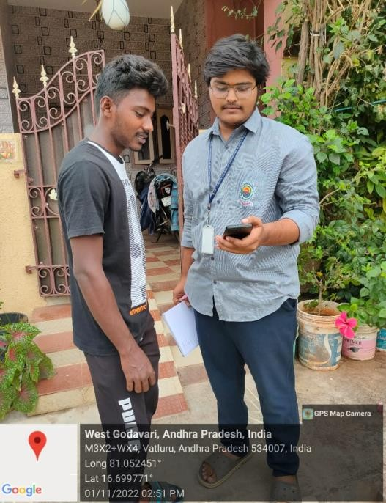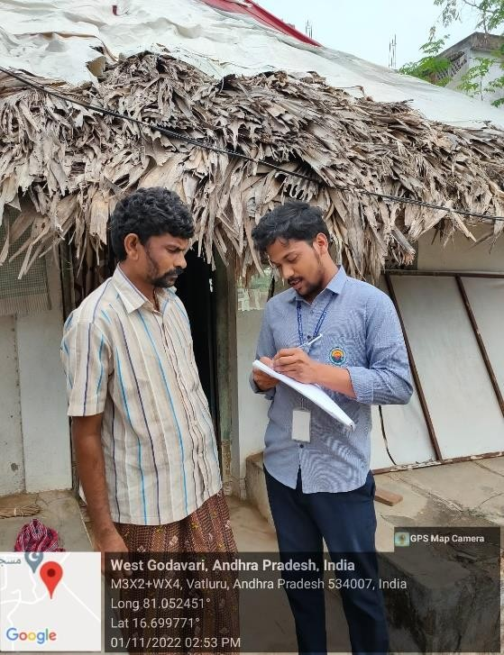

Name: P.SATHWIK RAM Name:P.NIKHIL

Regd No:20B81A05D9 Regd No:20B81A05D6

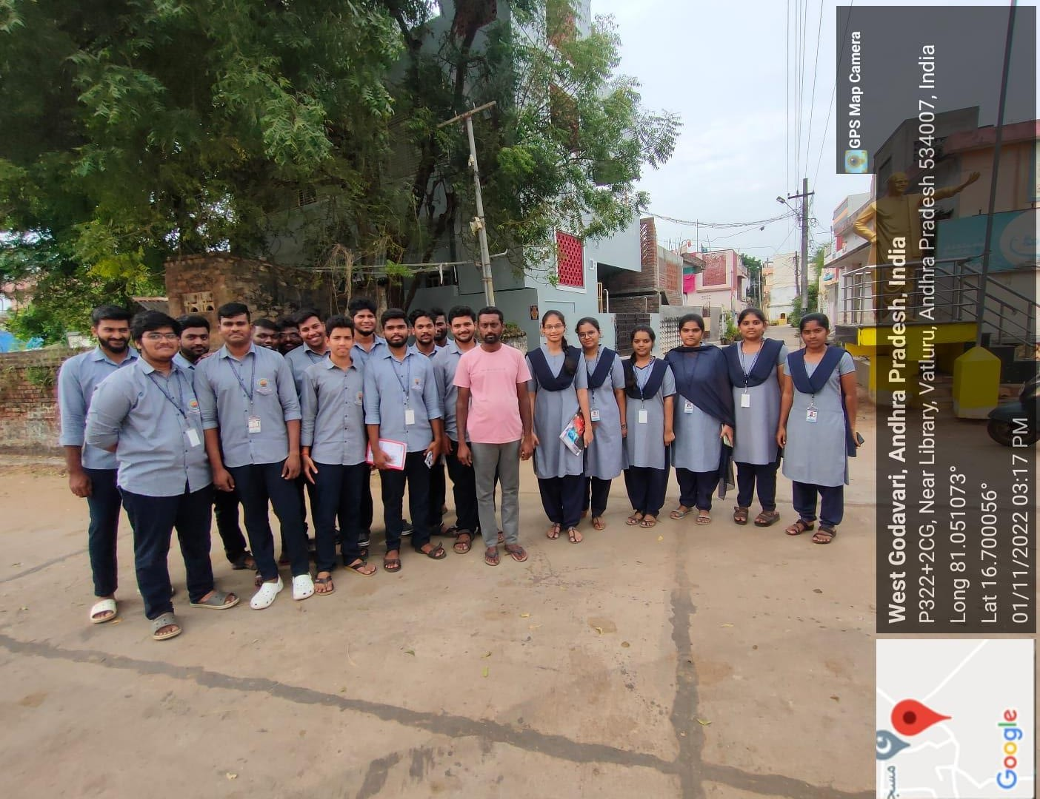

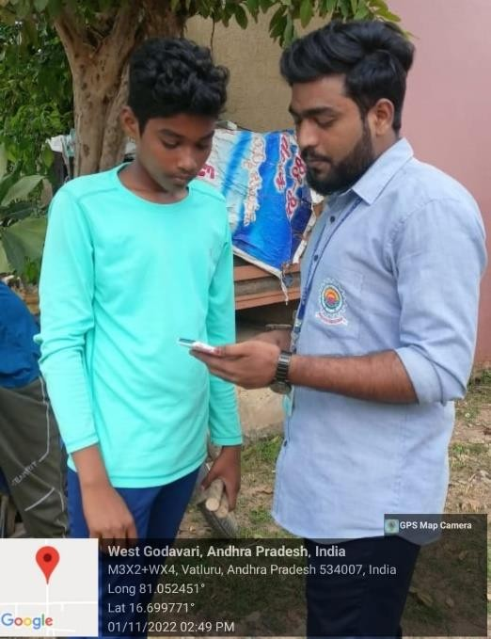 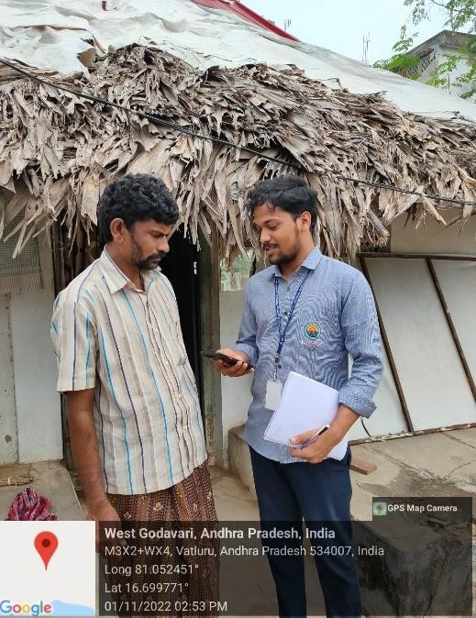

Name S.SAI KUMA Name P.NIKHIL

Regd No:20B81A05F1 Regd No:20B81A05D6

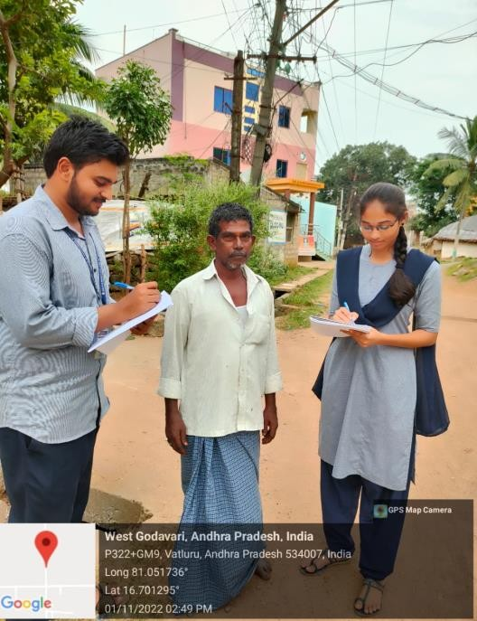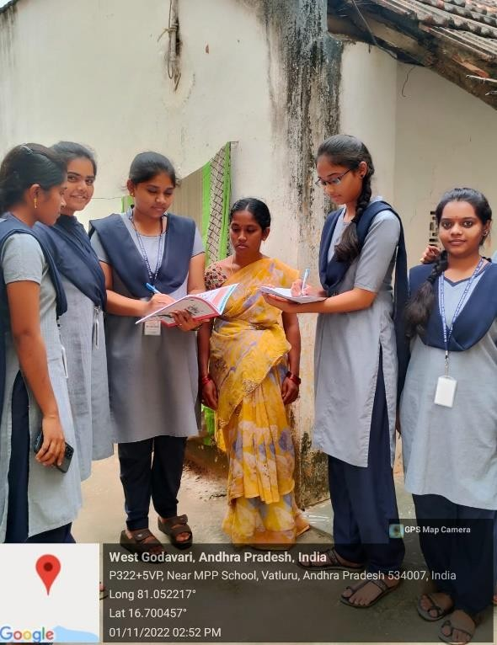

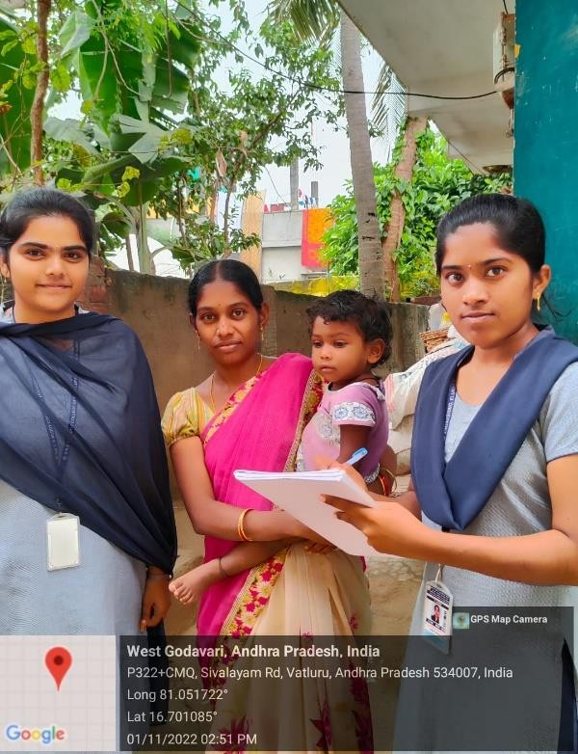 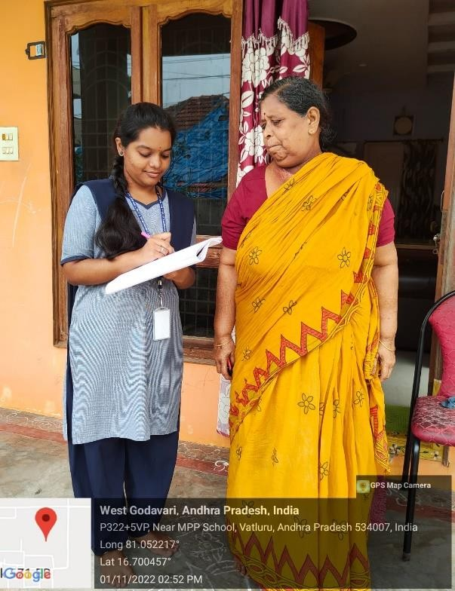

Name: R.ANJANEYULUA

Regd No:20B81A05E4

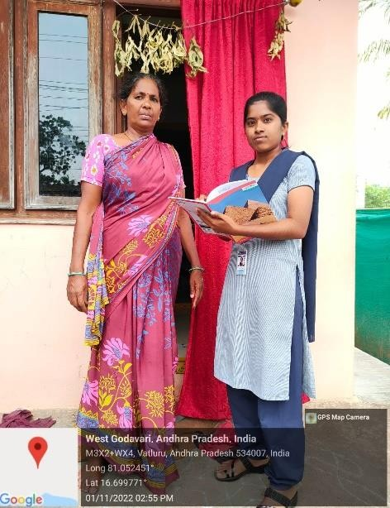

Name: S.JHANSI

Regd No:20B81A05E9

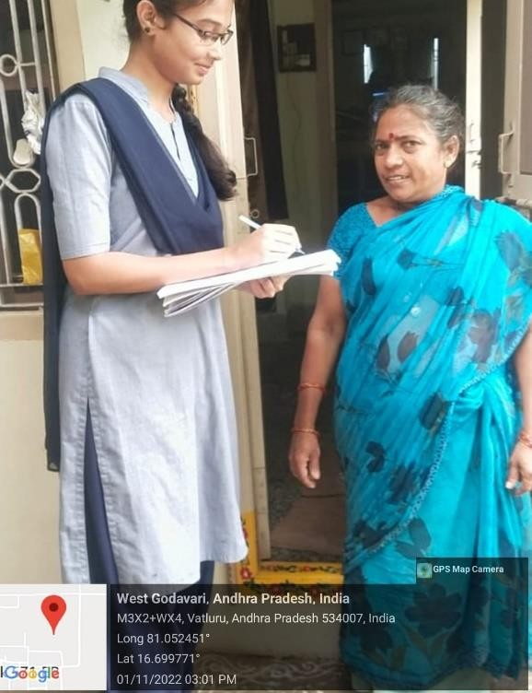 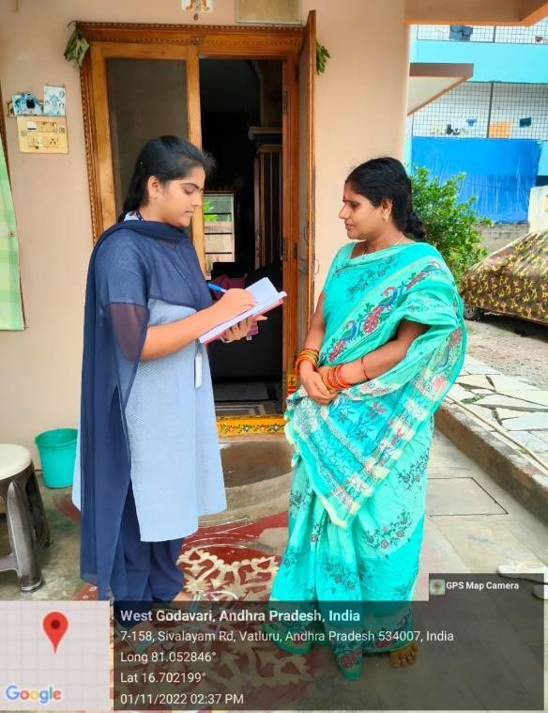

Name: R.JAHNAVI Name: S.HARIKA

Regd No:20B81A05E7 Regd No:20B81A05E8

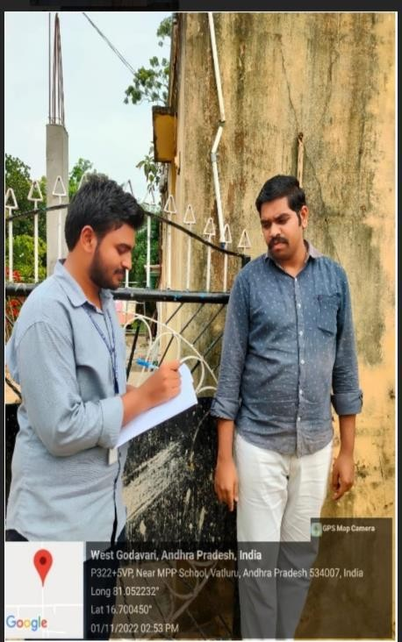

Name: R.NAGA KALYAN

Regd No:20B81A05E6

RATE ANALYSIS

### Association between duration of Mobile Phone use with age of respondents, Physical and Mental hazards.

|  |  |  |  |
| --- | --- | --- | --- |
| Column1 | column2 | column3 | column4 |
| Variable f mobile phone use/24 hrs | | | |
| N(%) | <5hrs N(%) | 5-10hrs N(%) | > 10hrs |
| Age group(in years) | | | |
| >25 | 25 | 35 | 2 |
| 26-35 | 23 | 19 | 2 |
| 36-45 | 16 | 12 | 2 |
| >45 | 0 | 2 | 0 |
|  | | | |
| Physical discomfort |  | frequency |  |
| Pain in shoulder |  | 30 |  |
| Pain in hand |  | 19 |  |
| Backpain |  | 25 |  |
| Blurring of vision |  | 0 |  |
| Headache |  | 64 |  |
| Eye pain |  | 52 |  |
| Mental hazards | | | |
| Dizziness |  | 21 |  |
| Inattention |  | 0 |  |
| Anxiety |  | 45 |  |
| Tension |  | 46 |  |
| Emotional imbalance |  | 34 |  |
|  | | | |

Information related to physical and mental hazards due to use of smart mobile devices

|  |
| --- |
| Variable frequency |
| Physical discomfort |
| Yes 129 |
| No 11 |
| Type of physical discomfort |
| Pain in shoulder 30 |
| pain in hand 19 |
| Backpain 25 |
| Headache 64 |
| Eye pain 52 |
| Feeling of mental symptoms |
| Lack of concentration 0 |
| Anxiety 45 |
| Emotional imbalance 34 |
| Poor academic performance 0 |
| Vertigo 0 |
| Ear problem |
| Yes 48 |
| No 92 |

### Distribution of respondants by opinion on impact of Mobile Device hamparing family life and Time

|  |
| --- |
| Distribution of respondents by frequency opinion |
| Type of impact(n=208) |
| Increase family demand 44 |
| Reduce quality family time 48 |
| Increase distance between family 46  Members |
| Others 11 |
| None 15 |

|  |
| --- |
| Column1 Column2 Column3 Column4 Column5 Column6 Column7 |
| Pattern of use smart mobile devices frequency |
| Purpose of use of smart mobile phone |
| Communication with others 45 |
| Entertainment 50 |
| Study purpose 38 |
| Job purpose 7 |
| Duration of use in 24 hours |
| <5 80 |
| 5 to 10 56 |

|  |
| --- |
| >10 4 |
| Use of other electronic devices |
| Yes 36 |
| No 104 |
| Type of other electronic devices used |
| Computer 9 |
| Laptop 23 |
| Tablet 7 |
| Purpose of use of other electronic device |
| For Study purpose 23 |
| Communication with others - |
| For work 11 |
| Entertainment 6 |
| Others - |
| Use of earphone |
| Yes 109 |
| No 31 |
| Duration of using smart phone before sleep at night(in hours) |
| <1 75 |
| 1 to 2 58 |
| 2 to 3 5 |
| >4 2 |
| Month expense for use and maintainence of smart devices |

|  |
| --- |
| <500tk 108 |
| 500-1000tk 28 |
| 1000-2000tk - |
| >3000tk - |

|  |
| --- |
| Column1 Column2 Column3 |
| Information related to Facebookuse |
| Variables frequency |
| Facebook use |
| Yes 82 |
| No 58 |
| Duration of Facebook usage (in hours) |
| <5 79 |
| 5 to 10 4 |
| >10 0 |
| Facebook friends |
| <100 49 |
| 100-500 24 |
| 500-1000 2 |
| >1000 1 |
| Ways of sharing feelings |
| By giving like 71 |
| By writing comments 13 |
| By uploading photos 11 |
| Other 0 |
| Purpose of Facebook use |
| Social communication 25 |
| Recreation & entertainment 53 |

32 Members are using Facebook 52 members are not using Association between Ear Problem and use of Earphone/Mobile Phone

|  |  |
| --- | --- |
| Ear problem | Number |
| Yes | 48 |
| No | 92 |

Relationship between family members and friend

Chart Title

80

70

60

50

40

30

20

10

0

1

3

5

Series 1 Series 2 Series 3

### MONTHLY EXPENSES

Chart Title

50

45

40

35

30

25

20

15

10

5

0

Parents

myself

Others

Series 1 Column2 Column1

ANALYSIS OF THE PROBLEMS

##### ANALYSIS OF THE PROBLEMS

Smart phones may be transportable that provides advanced technologies with usefulness similar as a non-public portable computer problematic smartphone use is proposed by some researchers to be a form of psychological or behavioural dependence on self phones closely related to others phones of digital media over use such as social media addiction or internet addiction disorder.

* Smartphone addiction has negative impacts on student learning and overall academic performance the greater the use of a phone the behaviour analysis of the smartphones. Smartphone addicts especially teenagers find it really hard to sleep at night. It’s easy enough to avoid the psychological Down side of smartphone habit. Here are the fixes for potential health risks.
* Mobile while driving significantly increase the risk of traffic accidents to the understand the risks and possible affects of phone use. Suggest that mobile phone’s aren’t harmful but long term risks, using a landline phone if one available keeping your mobile phone calls short using a hand free kit
* The people are empowered has they access information and interact with everyone on the go a part from all the above mobile phone may be used for entertainment are playing games, However there are many negative affects of mobile phones or smart phones. Quite a number of researchers have made systematic study on evil affects mobile phones or smart phones on human health.
* The mobile tower’s are much more dangerous for human beings. In the present the author tired to collect various data from different ages of people are using smartphones that are more dangerous in these days. Smart phone is no Longer just a communication device it’s public enemy blamed for everything from destroying family
* Smart phone addicts especially teenagers find it really hard to sleep at night. A good sleep at night is essential for brain normal activity. Smart phone use are adolescent aged 14 to 18 years. However younger children also appear to suffer from problematic

smartphone use according, smart phone use may differ with in some of those age groups especially younger people. Eye strain spending hours looking at the small screen of your mobile phone can do mare damage to your eyes.

## PROBLEMS IDENTIFIED

##### Problems Identified

* Smartphones and mobile devices are used in day-to-day life.They are used by the humankind across the world.
* They have both positive and negative impact on humans’ life.
* Smartphones are extremely convenient They allow us to communicate in multiple ways.
* You can text email, call. Video chat, use social media apps to stay in contact with anyone anywhere.
* Technology has made its way into every facet of our lives and helps to make life easier and more functional.
* The available scientific date on exposure to radio frequency energy show no categorical proof of any adverse biological effects other than tissue heating.
* Public health data show no association between exposure to radio frequency energy from cell phone use and health problems.
* Studies show that people addicted to mobile phones often are linked to depression, anxiety, and other Mental disorders.

###### Waste of time:

* The average person checks his phone checks his phone once every 12mintues, leading to 80 times a day.
* Most of the time people just check their phones for no good reason.
* There is a concern that microwaves might induce or promote cancer as a symptoms associated with their use include sleep disturbances, memory problems, headaches, nausea, dizziness.
* Changes in the permutability of the blood brain barrier, electroencephalographic activity and blood pressure also have been reported.
* Effect on health
* According to the findings of study and research – The mobile phones has the potential to influence many parts of body.

###### Tumours that aren’t cancerous:

* According to the experts use of phone and keep the phone near the head while sleeping are primary causes of brain and ear Cancer:
* Because mobile phone radiation impacts children more than adult brain, this radiation effects children brain twice as much adult brain.

###### Effect on the mind:

* The usage of a smart phone has a direct impact on children’s brains which may create serious problems in young children.
* Some children may have mental problems as a result of their usage of the phone, their academic abilities will deteriorate day by day. They will be some behavioural issues, and so on.
* Academics:
* Students are solely interested in talking with friends and playing games because of smartphone technology.
* This student distraction will damage the children’s education since they will miss all of the subjects that are being taught.
* There will be a difficulty in the studies or fall academics as are a result of this.

## RECOMMENDATIONS

#### RECOMMENDATIONS

The researcher in this study had given some clear recommendations from all sides of theconsidering the nature of mobile phone use in the developing countries.

By analyzing the data from the societal, and psychological, financial and political all the aspectswere described in details in this part.

###### RECOMMMNDATIONS FROM SOCIETAL SIDE

* “Mobile phones have become a very human attracting technological device not only but also allover the world.
* Social crimes are increasing by using mobile phone government should be realistic to theproactive in making law regarding this issue.
* Emotional disruption.
* By using mobile phone, we can enter any site of the web;we should be strong in morality thatwe don’t use our mobile phone for visiting by restricted sites.
* Creating and building awerness among our young generations from society to proper useof mobile phone.

###### RECOMMENDATIONS FROM THE PSYCHOLOGICAL SIDE

* By taking the conversation via mobile phone male and female are to be a liar of the because any one cannot see them when theyare in a conversation everyone should be abletransparent in their mobile conversation that the should be psychological moral in using the Technology.
* Emotional attachment with mobile phone is very easy practice in Bangladesh, normally in theyoung generations they easily lose their emotion via phone all the users of the mobile phoneshould be more aware while using the mobile phone.
* *Radical change their behavior: mobile phone can change the human behavior.radically in theirnature use mobile phone for the mobile self-development and self-prospect in such a way thatmobile phone cannot affect their life style.

###### RECOMMENDATIONS FROM THE FINANCIAL SIDE

* Money is circulated every day because of mobile phone use.
* Mobile related industry should be established by taking Government initiative that can be thecreate a smooth flow of money.
* “Mobile phone can be a huge source of employment opportunity directly or indirectly a largenumber of people can involve in this sectors.
* By using mobile phone in we can create a good flow of money circulation which can help tomake a sustainable GDP for our country.

###### D.RECOMMENDATIONS FROM THE POLITICAL SIDE

* Political party in the world can use good side of mobile phone for their political agenda.
* Political party can change the nature of any country this party should use the mobile phone for the development of their country.
* The above discussion and partial of the experimental evidence inspire us there atrecommending that people.
* Avoid wearing a cell phone close to the body even in stand by Mode.
* Minimize the number of cell phone of the conversations.
* “Use”hands-free”or”blue tooth-headset”, such that during a conversation the cell phone is keptas far from the body as possible.
* “Avoid using a cell phone when the signal is not strong, especially in closed spaces, such aselevator, metro, and so on and also Avoid using the phone during a high speed move.
* Move the cell phone from one side of the head to the other, during a long phone conversation.
* “Observe the SAR level of the cell phone they are to purchase aiming at devices whose SARvalue is low.
* Avoid letting children (who are very sensitive to electromagneticelectromagnetic waves )use cell phones.

## CONCLUSION

#### Conclusion

We discussed mobile Devices effect on human. Considering in particular the electromagnetic waves and the way they are affecting. There search on smartphone usage in Indian context are still limited as can be seen from the review above there are only few studies on smartphone use been conducted among the Indian students. The study participants were aware about mobile phone by radiation hazards and many of them were extremely dependent on smart phones one- fourth of the study population

We found having feeling of wristand hand pain because of smart phones use which may lead to further phsychological and psychological complications use of mobiles mart devices acts risk factor for development of various types of diseases in human body and our family life. Thus it is suggested that excessive use of mobile phone should be social awareness should be increased through health pologrammes In this research we tried to bring attention to the potential risks that cell phones and other devices cause to users and provides some solutions a show to mitigate side effects of cell phones and mobile devices on the users limiting its use.

It is true that smart phones has a Size able impact on society other aspects of life .The enormous usage of these devices by ser states that the size of impact .Consumers are in process of egotiation sway from the use of conventional cell phones as their smart phones are begging the past of the society .A new phobia hasdeveloped known as “NOMOPHOBIA”/fear of being without a phone/is very common problem found among teenagers.

Past studies in India focus on Investigation the duration of time students spent on smart phones,activitiesd one on smart phones an ididentify students such as psychological impactor Social impact on smart phones use on lives are still lacking.

Moreover, research and problematic smart phone use among the Indian student population has never been explored from various aspects .The main purpose of this review is to identify the motive of the students in utilizing their smart phones and negative effects of smart phone use on students psychological health, education and socialization.

Furthermore, to review and Previous studies and smart phone used conducted in India. The finding of this smart phones that can influence student’s life. Further more, the finding could encourage researchers in this field to investigate method to over come the negative effects that student might face of their overused their smart phone in their routine life.

## BIBLIOGRAPHY

#### REFERENCE

* Acharya JP, Acharya 1,waghrey D. A study one some of the health effects of cell phones amongst college students. J community Med Health Edu. 2013:3:214
* Abowd, G. D., At Keson, C. G., Word, J. Long, S. Looper, R and Pinkston, M(1997) cyberguide :A mobile content – aware tour guid, wirelessnetworks.
* Sudan M, Kheifets L, Arach OA, Olsen J(2013) cell phone exposures and hearing loss in children in the Danish National Birth Cohort. Peaoliatric and perinatal epidemiology. 27:247 257.
* Abu-Shanab, E. (2015). The influence of smart phone on Human health and behavior.
* Jordanians perceptions. International Tournal of computer networks and applications, 2(2),52-56.
* Anderson, K. E(2016).Getting acquainted with social networks and apps Instagrams instant appeal. Library Hi Tech News, 33(3),11-15.
* Navid U, Rashid N, Sultan Queen. Implication of facebook usage on social behavior of teenages in Public and private institutes of Lahore Biomedica. 2017; 33(1):14-9.
* *Yourself M, Mansour T, Abdel Salam HA. The relationship between mobile phone use and ear problems among medical students. Biomed 2016;27(4):1251-4.
* Meo SA, Al-Dress AM. Mobile phone related – hazards and aubjective hearing and visionssymptoms in the Saudi Sosuation Int J occup Med Environ Health.2005;18(1):53-7. Mutha Kapil. Sumedh Hobskote S, Shashank Joshi R. Health

Hazards of mobile phones: AN Indian perspective, 2008,5 6. Dr.Abdullah Orainy A1. Recent research on Mobile PH Effect Electromagnetic Field & Our Health. 20th – 22, 2003.

* Tesa Jones. Students Cell Phone Addiction and their opinions. The Elon Journal of Ungraduate Research in Communications 2014,5(1).
* Dambhare, S., Parjane, M. & Deore, D. (2012).Touch Screen Based Menu Ordering & Displaying System for restaurants. International Journal of Computer Engineering and Technology, Vol. 3(2), pp. 168-172.
* Hamada A, Singh A, Agarwal A(2011) Cell phones and their Impact on Mobile fertility Fact or Fiction. Then Open Reprod SCP J5:125-137.
* Bianchiy A, Phillips JG (2005) Psychological predictors of problem mobile phone use. Cyber Psychol Behav 8:39-51.

## QUESTIONNAIRE

#### SIR CR REDDY COLLEGE OF ENGINEERING

###### AN OPINION SURVEY OF

**THE IMPACT OF SMART PHONES AND MOBILE DEVICES ON HUMAN HEALTH AND LIFE**

###### QUESTIONNAIRE (A SAMPLE SURVEY)

1. Name:
2. Age:
3. Male/Female:
4. Religion:
5. Qualification:
6. Occupation:
7. Type of Family:
8. Marital Status (Married/Unmarried):

9 Monthly family income:

10 Purpose of use of smart mobile Phone:

1. Duration of use in 24 hours :
   1. <5 hours
   2. 5-10 hours
   3. >10 hours
2. Type of other electronic devices used:
   1. Computer
   2. Laptop
   3. Tablet
3. Purpose of use other electronic devices:
4. Duration of using smart phone before sleep at night in hours:
5. Monthly expense for use and maintenance of smart devices: 16.Face book use:
   1. Yes
   2. No
6. Duration of Facebook usage in hours:
   1. <5 hours
   2. 5-10 hours
   3. >10 hours
7. Facebook friends:
8. Ways of sharing feelings:
9. Giving like
10. Comment
11. Upload photos
12. Others.
13. purpose of Facebook use:
14. Physical discomfort:
    1. .Yes
    2. No

22 Type of physical Discomfort:

1. pain in shoulder.
2. Pain in hand
3. back pain
4. headache
5. Eye pain
6. Eye problem:
7. Type of impact:
   1. Increase family demand
   2. Reduce quality family times
   3. Increase distance between family members
   4. Others
   5. None 25.Mental Hazards:
8. Anxiety
9. Tension
10. Emotional imbalance
11. Dizziness